Christmas/Winter home learning activity ideas
Fake Snow  We may not be getting a white Christmas this year but there is no need to miss out. You can make fake snow using just cornflour and bi-carbonate of soda (see recipe below). Encourage the children to help you to make it – they will love exploring the consistency and trying to build their own snowmen!  https://www.bbcgoodfood.com/howto/guide/how-make-fake-snow  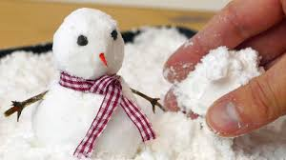  Understanding the World – exploring properties of materials and investigating change. | Ice Play  Provide ice cubes or freeze toys inside ice and encourage children to excavate them  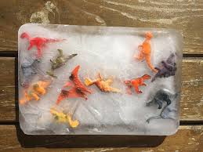  Understanding the World- learn about changes and differences.  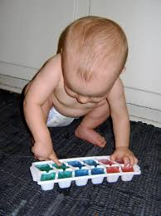  Communication and Language- opportunities to experiment with language and descriptive words.  Physical- encourages children to manipulate, building up fine motor skills and co-ordination.
Rice Crispie Shapes  Follow this simple recipe to make some delicious treats. Perhaps you can make them to share with family or friends in your bubble if you will be spending time with them over the holidays.  https://www.goodto.com/recipes/rice-krispie-stars-and-sprinkles  Mathematics – involve the children in weighing, measuring and comparing quantities.  Understanding the World – use your senses to explore the ingredients – how does it look, smell, feel, taste? Talk about the changes that happen when the ingredients are mixed.  Physical Development – using tools and equipment safely | The Christmas Story  At Nursery we celebrate all religions and festivals, teaching the children that we are all different and that we celebrate different things. This link gives a very simple introduction to the Christian story of Christmas.  https://www.bbc.co.uk/cbeebies/watch/presenters-nativity-story  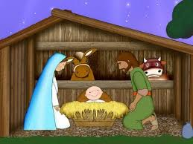  core value – we are all different  understanding the world – joining in with family customs and celebrations.
Winter Scavenger Hunt  It may be cold but wrap up warm and go on a walk in the local area. Create a list of things to look for on your walk – the children will love ticking off the things they find and it may be a welcome distraction from the exercise! E.g. lights, a bare tree, Christmas tree, Reindeer, Robin, animal tracks, berries, squirrel, a frosted leaf. You could also take some blank paper for the children to write or draw some of the other things they see.  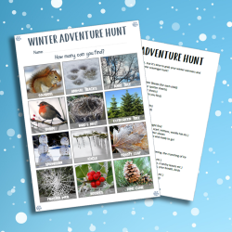  Physical Development – exercising together as a family  Understanding the World – noticing and talking about features in the local environment | Christmas Cards  The children love giving cards to each other and are often posting them in our role play post-boxes. Provide materials to make cards or buy ready made Christmas cards for the children to write. I’m sure they will be keen to talk about their friends and family whilst writing their cards. Make it extra special by walking to the post box to post your cards together.  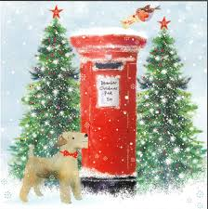  Personal, Social & Emotional Development – recognising and talking about special people  Literacy – mark making/writing for a purpose
Baking Gingerbread Men  Gingerbread men recipe - BBC Food  Follow the recipe to make your own delicious gingerbread men. There is so much learning involved in cooking including...  Reading – look at the recipe together. Talk about the ingredient list and numbered instructions.  Maths – involve the children in weighing, measuring and comparing quantities.  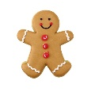  Understanding the World – explore using all of your senses, and investigate what happens as the ingredients are mixed and baked.  This Photo by Unknown Author is licensed under CC BY-NC-ND | Santa’s Wish List  A possible visit from Santa can be a wonderful way to encourage children to engage in mark making and writing. Support your child to write a letter or a list for Santa – cutting pages from catalogues can add extra excitement.  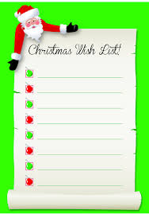  Physical development – using one handed tools safely and effectively  Literacy – writing for a purpose
Snowflakes  At Nursery we love decorations! Why not make some snowflakes at home. Younger children can do this by sticking lollypop sticks together and decorating them. The older children can develop their cutting skills by folding paper and snipping or cutting. Provide different resources to decorate the snowflakes – glitter is always very popular here.  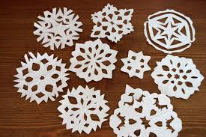  Expressive Arts and Design – exploring materials  Physical development – using scissors safely and effectively. | Winter Stories  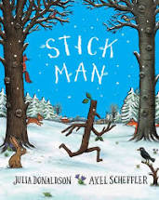  Share some winter stories together, talking about the characters, setting and main events. We love The Gruffalo’s Child and Stickman by Julia Donaldson. If you do not have them at home don’t worry – you can always watch or listen to them being read on YouTube. Kerrie will also be sharing some stories on our Facebook page during the holiday.  Literacy – sharing stories, talking about characters and main events.
Cosmic Kids Yoga  winter cosmic yoga - YouTube  Cosmic Kids Yoga has many different Winter themes – polar bears, Frozen, Christmas – there is something for everyone. Choose a theme to enjoy together, taking part in physical activity whilst also promoting well-being and mindfulness.  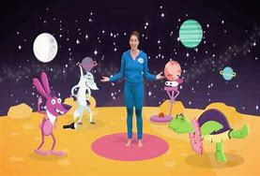  Physical Development – moving in a variety of ways, showing an awareness of the body.  PSED – relaxation and wellbeing | Penguin Waddle  This is a fun and silly game for all of the family to enjoy. Hold a balloon or ball between your legs and move around the room trying to keep it in place … you should find yourself waddling like a penguin  