The Ambleside Centre
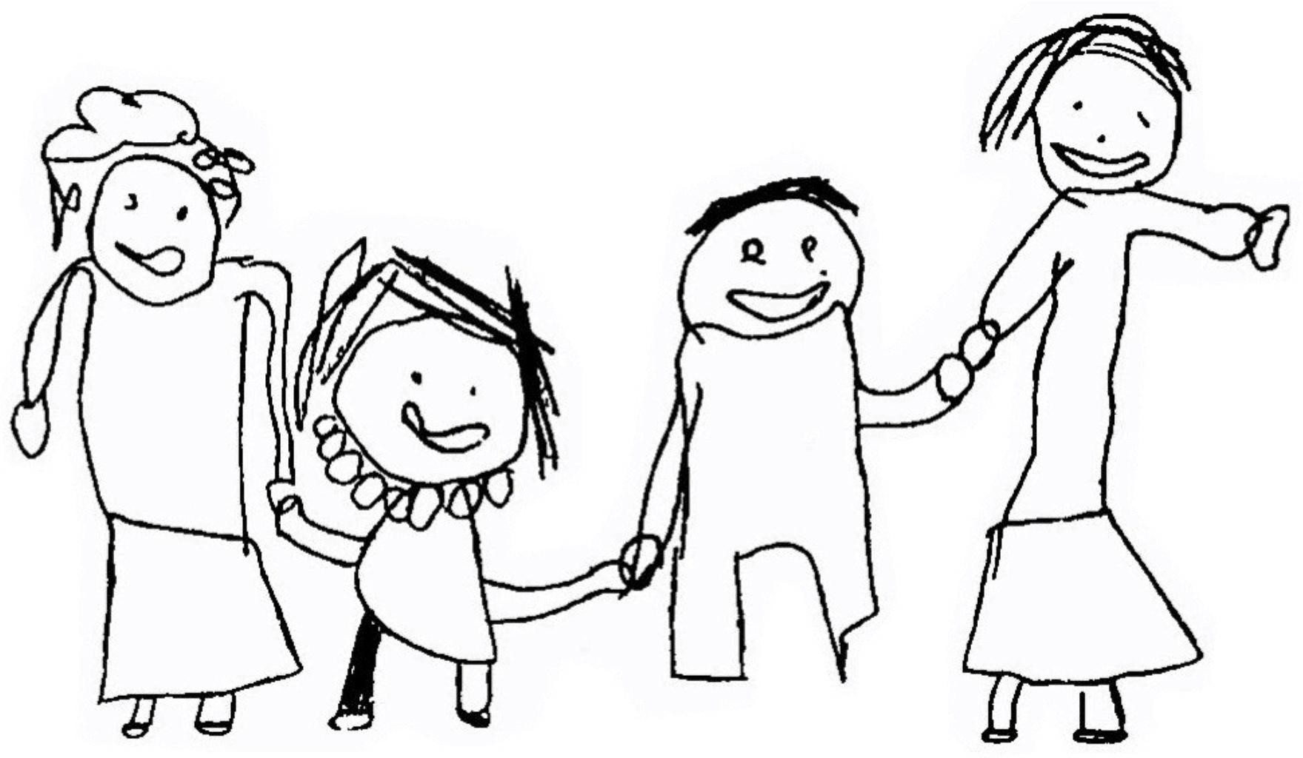

Safety Procedures (Staff Induction Pack)

Our aim is to ensure that all reasonable practical steps are taken to ensure the health, safety and welfare of all persons using the premises. To achieve this we will actively work towards the following objectives:

- To establish and maintain a safe and healthy environment throughout the Centre.

- To establish and maintain safe working procedures amongst staff and children.

- To make arrangements for ensuring safety and the absence of risks to health in connection with the use, handling, storage and transport of articles and substances.

- To ensure the provision of sufficient information, instruction and supervision to enable all people working in or using the Centre to avoid hazards and contribute positively to their own safety and health at work and to ensure that they have access to health and safety training as and when provided.

- To maintain a safe and healthy place of work and safe access and exits from it.

- To formulate effective procedures for use in case of the emergency evacuation of the premises.

- To follow the regulations of the Health & Safety at Work Act 1974 and any other relevant legislation.

We believe that the centre is child friendly and presents low risk, but also that children need to be able to take some risks in a secure environment in order to learn and develop.

All staff are required to:

- Ensure high standards of cleanliness are maintained.

- Ensure safe and clear accesses and exits from the building.

- Regularly check the premises for structural defects, worn fixtures and fittings or electrical equipment, and take the necessary remedial action.

- Be aware of the emergency evacuation and lockdown procedures.

- Provide safe and sensitive care during nappy changing, toilet routines.

- Follow procedures in cases of first aid and accidents.

- Take all reasonable action to control the spread of infectious diseases and wear protective gloves and protective clothing where appropriate.

- Check equipment regularly and any dangerous items repaired / discarded.

- Ensure all visitors enter their details on the signing in sheet in reception.

- Use insulated lidded containers for hot drinks where children are present.

- Ensure that all electrical sockets are kept clear with no trailing wires.

- Place all cleaning materials out of the reach of children.

- Check all children sleeping regularly.

- Ensure that nuts e.g. peanuts are not allowed in the Nursery. Prohibit the use of raw kidney beans, egg shells, toilet roll holders and polystyrene chips by the children.

- Familiarise themselves with the details of children with medical conditions and allergies.

- Ensure that children are not left unsupervised at any time.

- Ensure that students are not left unsupervised at any time.

A breach of health and safety procedures by staff constitutes misconduct and will be dealt with as a disciplinary matter. Staff must constantly be mindful of their responsibilities individually and collectively for the safety of themselves and their colleagues.

Signed …………………………………………………….. Date …………………………………………………..

Position ……………………………………………………

